
SLING PSYCHROMETER
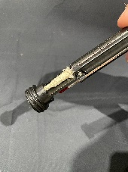 | Remove the cap by unscrewing it from the Sling.
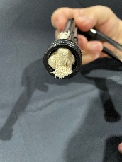 | Make sure the wick is installed in the reservoir | 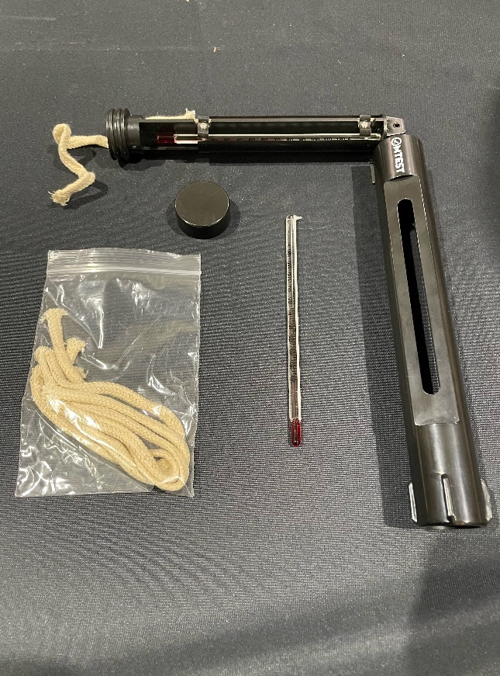  HANDLE  CAP  REPLACEMENT THERMOMETERS  WICKS  SCREWS  PIN  DRY BULB  WET BULB  WICK
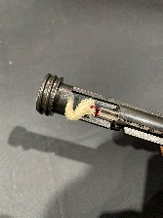 | Make sure the wick is installed on the wet bulb by bringing it through the hole and putting it over the bulb of the thermometer, making sure that it covers the bulb completely.
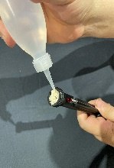 | Use Deionized (DI) or Distilled water to thoroughly wet the wick.
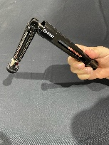 | Make sure the barrel is fully extended.
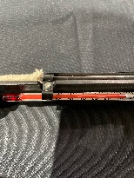 | Read and record the dry bulb thermometer.
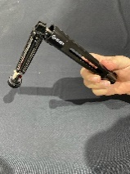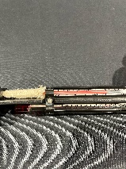 | While using the handle (The side without the thermometers) in the shade or with your back to the sun – Whirl for about 1 ½ minutes and read the wet bulb thermometer. Repeat for 30 seconds. Note if the wet bulb has changed. If it has – repeat until the web bub does not change.
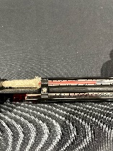 | Record the wet bulb reading
 | Use Psychometric table of an online calculator or phone app to calculate the Relative Humidity (RH) and Dew Point (DP)

OPERATIONS
- Make sure the wick is saturated (preferably with DI or Distilled water). This will increase the life of the wick.
- If the wick is Hard to the touch or tan or brown instead of white, remove that portion of the wick with scissors and put on a part of the wick that is white and soft. For correct readings, replace the wick if necessary.
- Make sure the part of the wet bulb on the bulb is “wet”
- Pull the body out of the Handle and make sure the sling can swivel.
- Make sure the thermometers are not split. Before swirling, the Wet bulb and Dry bulb should be close to each other.
- Before swirling, read and record the Dry Bulb Thermometer. Make sure the Sling is close to the Ambient Temperature before using. This may take 10 to 20 minutes if you get it out of a hot car. This can cause reading to be off.
- Check the thermometers. Make sure the Red Spirit is continuous and does not have any gaps. If it does, replace the thermometer before using.
- Readings should be taken in the shade and not direct sunlight. If shade is not available, use your body to shade the sling from the sun if possible.
- Make sure the wick is wet, soft and white. If hard or tan, it should be replaced.
- Swirl the sling for 1 ½ minutes. Read the wet bulb temperature.
- Swirl for an additional 30 seconds. If the temperature is the same, record the wet bulb temperature. If not, repeat until you get the same reading a second time and record the reading.
- Use a psychometric table or one of the numerous online apps to get Relative Humidity and Dew Point.
USERS NOTES:
Reading the Dry Bulb after the sling, may result in inaccurate readings, especially in HOT weather >85°F. Under these conditions, if comparing them with a properly calibrated electronic meter, the electronic meter is generally More accurate.
To check the accuracy of the thermometers, put them in a glass of water filled 2/3 with ice. They should read 32°F ±1°F
APPLICATION AND ACCURACY
Wet bulb readings should be taken immediately after swirling because the reading on the thermometer will begin to increase once the swirling is stopped.
Range of Relativity Humidity is between 10% and 100%
Barometric pressure can affect the RH and DP but for most locations, using sea level pressure is sufficient. If you are working at extreme altitudes, you may want to find a computer application that allows for changes in atmospheric pressure or use a psychrometric table.
MAINTENANCE
Use DI or Distilled water (These can be purchased at any drugstore or supermarket)

If wick is hard or discolored, cut off the discolored part and replace with the clean part of the wick or replace the wick.
Make sure the reservoir stays wet. Pack wick as loosely as possible in the reservoir to make sure it stays wet.
Make sure the Red Spirit in the thermometers is continuous with no breaks in the red column.
CAUTION: Storing Slings in excessive temperatures, such as in a car in the summer, can damage the thermometers.

